Enterprise Infrastructure and Networks – IT-520-A

Mallika Regulla

Marymount University

**ASSIGNMENT:2**

1. Browser running http v 1.1

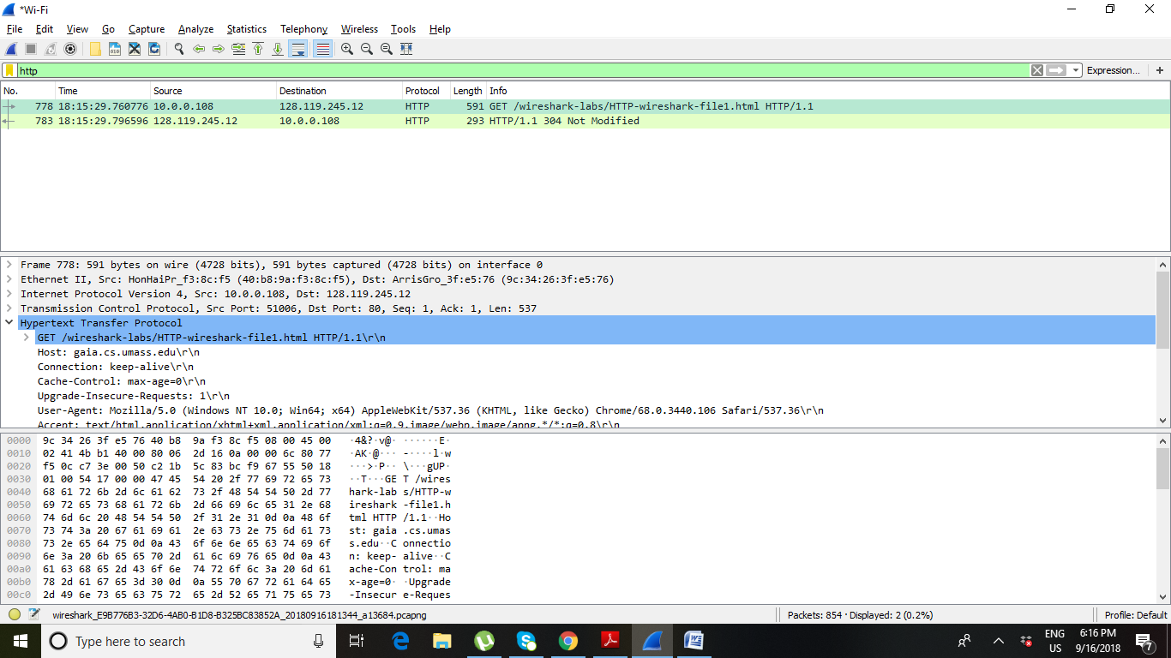

1. Modified 05.59.02 GMT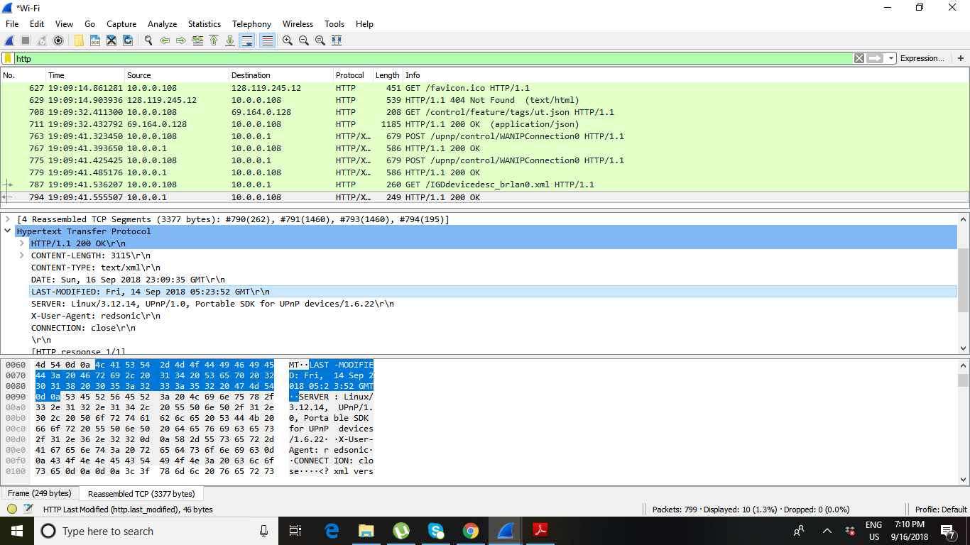

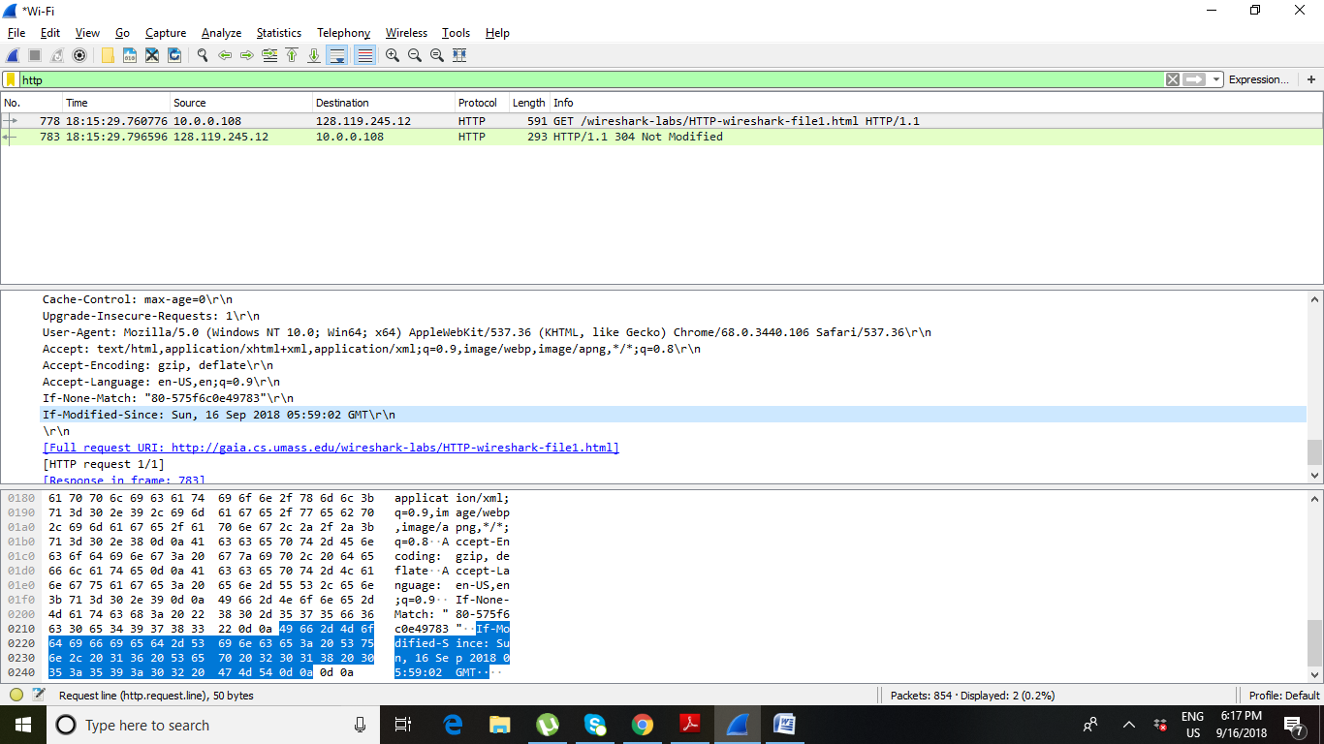

1. My computer IP address is 10.0.0.108 and IP address of gaia.cs.umass.edu.server is 128.119.245.12

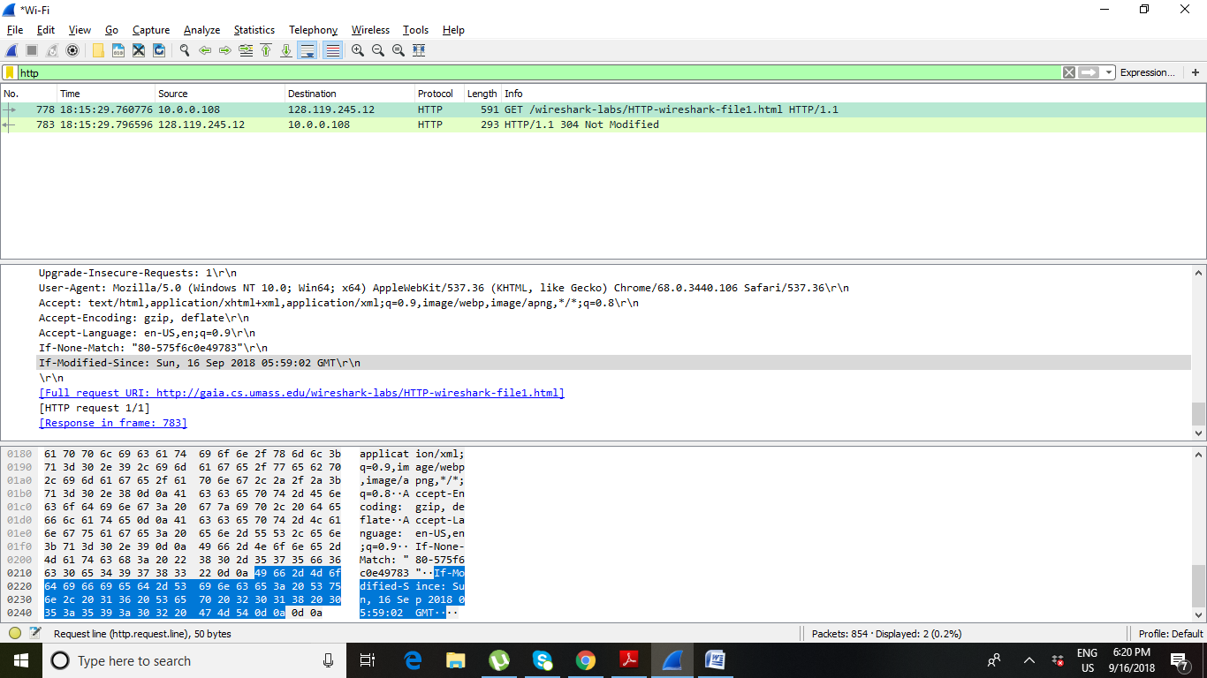

1. Language accepted is en-US (English USA), en (English)

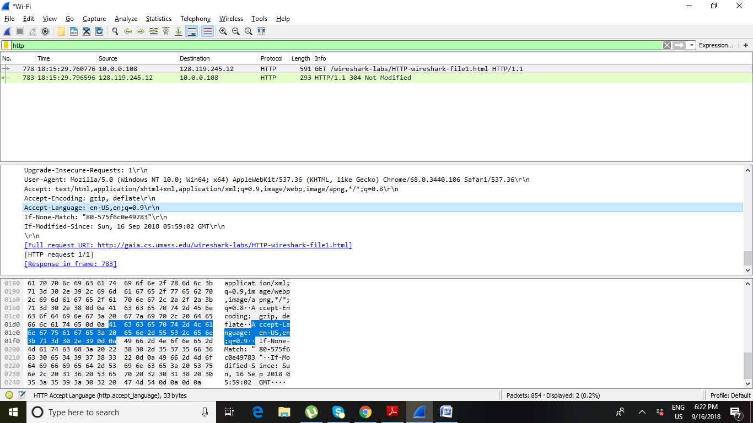

1. Modified 05.59.02 GMT

